**Wafer Fault Prediction:**

This is a simple wafer (sensor) fault classification prediction. It will predict the wafer is working or not based on the given training data. It is a binary classification problem, i.e. -1 is working, 1 is not working.

**Work flow:**

**Training:**

Start => Data(batch) for training => Data Pre-processing => Data Clustering =>Get Best model of each Cluster => Hyper parameter Tuning => Model Saving

**Prediction:**

Application start => Data(batch) for prediction => Data Pre-processing => Data Clustering => Model call for specific cluster => Prediction => Export Prediction to CSV => END

**requirements.txt** file consists of all the packages that al are required to run the project.

**Main.py** is the entry point of our application.

To train the model uncomment the below area.

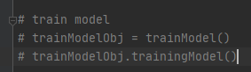

To prediction the model uncomment the below area.

